Gym Management System

Team Members:

* Muhammad Adil (2019-CS-20) **(Group Leader)**
* Uzair Tasawar (2019-CS-33)
* Syed Qaiser (2019-CS-34)
* Mazhar Khalid (2019-CS-35)
* Amjad Khan (2019-CS-45)

**Submitted to: Prof. Usman Asghar**

Detailed Explanation of the Project Classes:

Equipments:

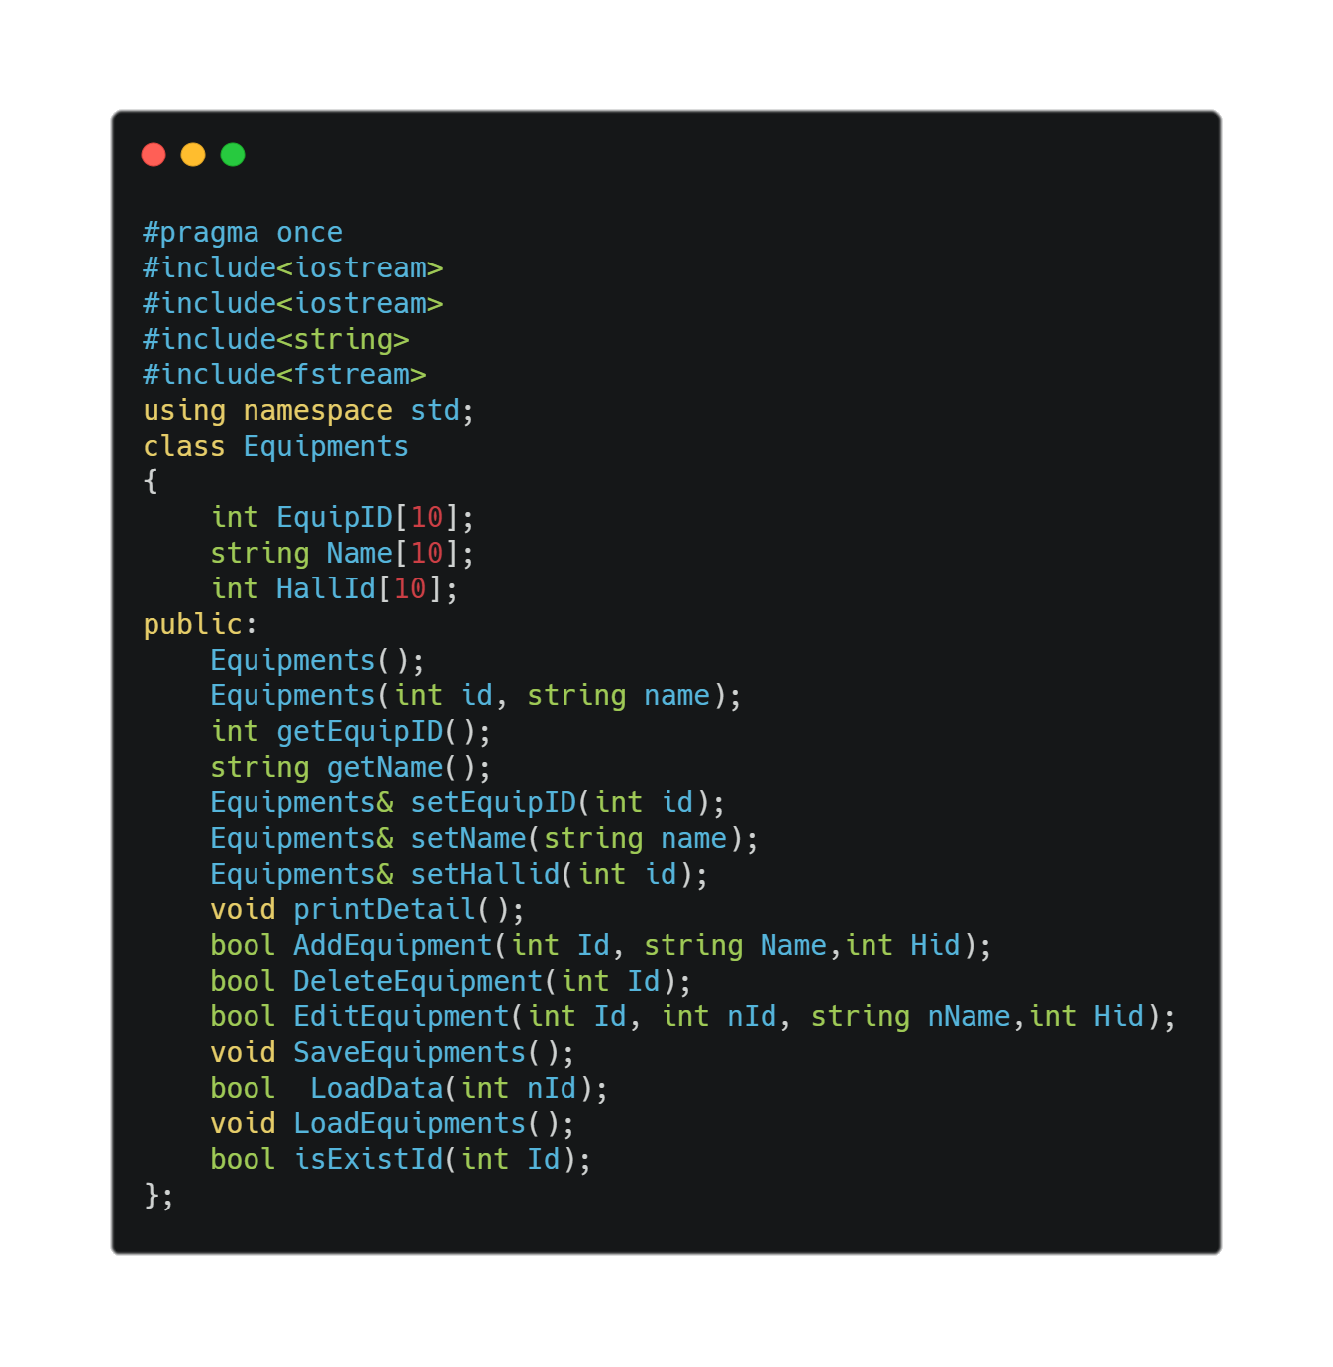 This portion of the Documentation shows the Final Classes and their Members Functions used in the Final Development of the Project:

This **Equipments Class** has some Basic Header Files included in it.

It has three Data Members **EquipId**, **Name** and **Hallid**.

The class has **Constructors (Default and Parameterized)** , **Setter and Getter Functions.** Add/Delete and Update **Equipments** Functions.

**LoadEquipments()** is responsible of Load the Data from Files into Data Members and **SaveEquipments()** is responsible of Saving Data into the Files .

The Null Constructor is the one mostly used in the Project.

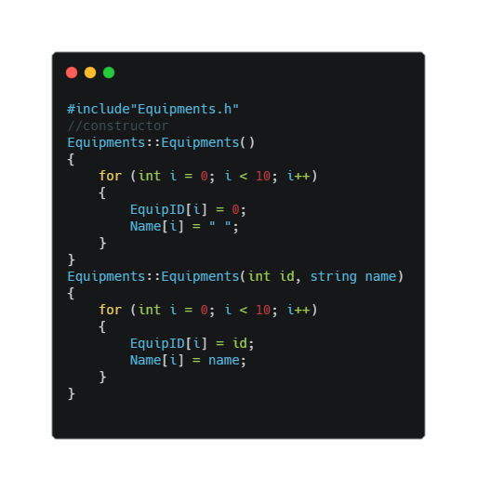

The **Null Constructor** Sets all the Data Members arrays to null.

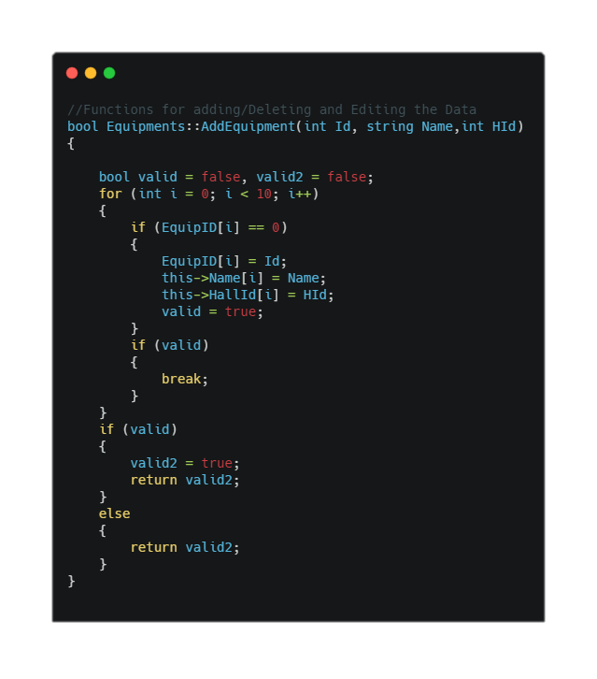The **AddEquipments()** functions take three arguments and check if the ID is null then it stores the Data at that location in the Data Member arrays. Its return type is **bool.**

The **DeleteEquipments()** takes one argument and checks if the Id already exits or not if the Id exists it nulls all the Data Members at that location. If not if gives Error . Its return type is bool.

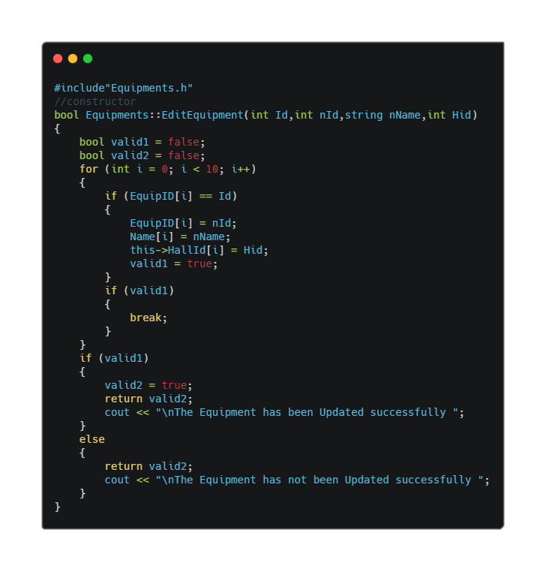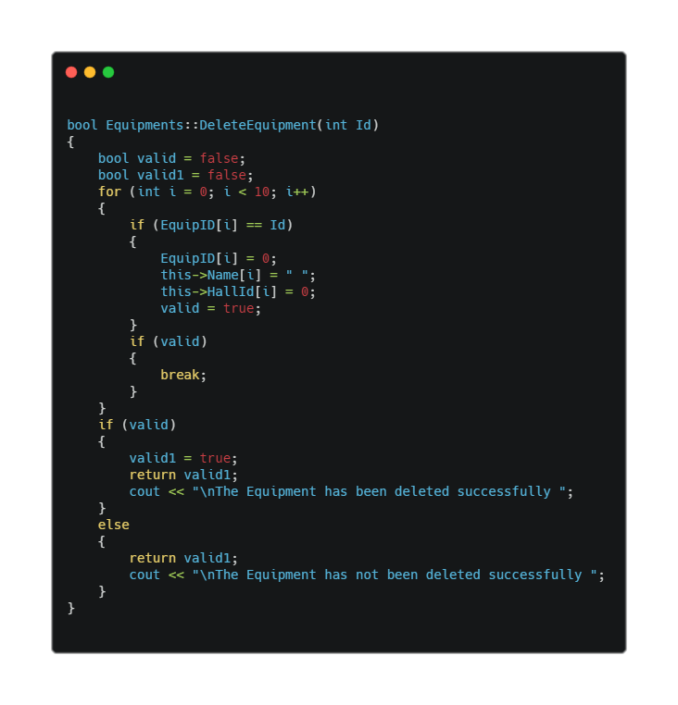The **EditEquipments()** takes four arguments and checks if the previous id Exists then if Yes, it stores data at that location.

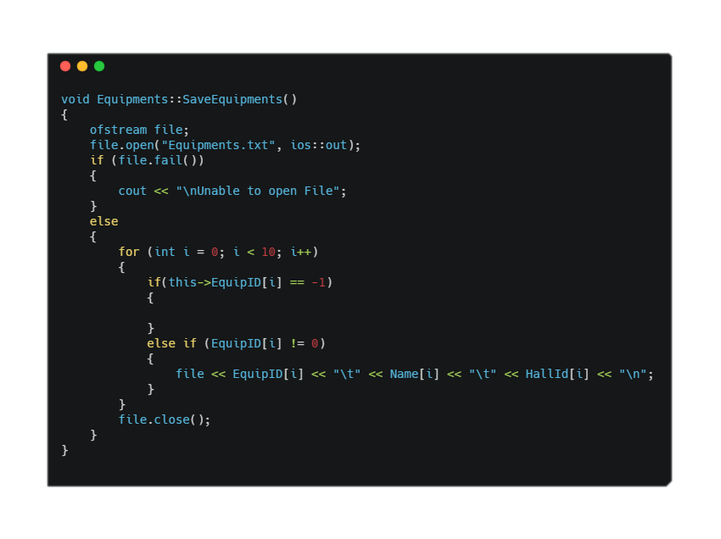The **SaveEquipments()** writes the data in the file “Equipments.txt”.

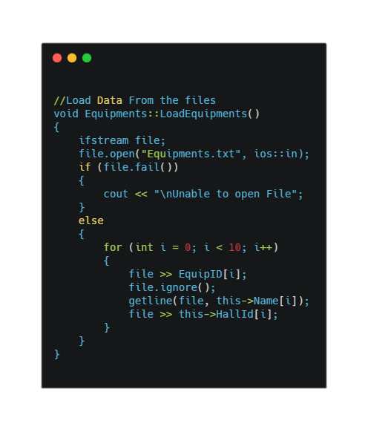The **LoadEquipments()** reads the file “Equipments.txt” and load the data in the Data Members.

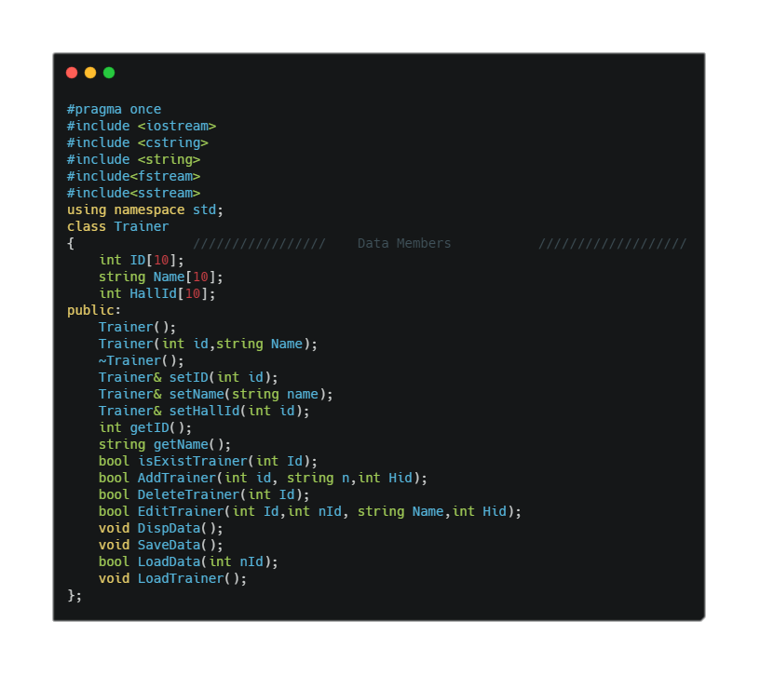Trainer:

This **Trainer Class** has some Basic Header Files included in it.

It has three Data Members **ID**, **Name** and **Hallid**.

The class has **Constructors (Default and Parameterized)**, **Setter and Getter Functions.** Add/Delete and Update **Trainer** Functions.

**LoadTrainer()** is responsible of Load the Data from Files into Data Members and **SaveData()** is responsible of Saving Data into the Files.

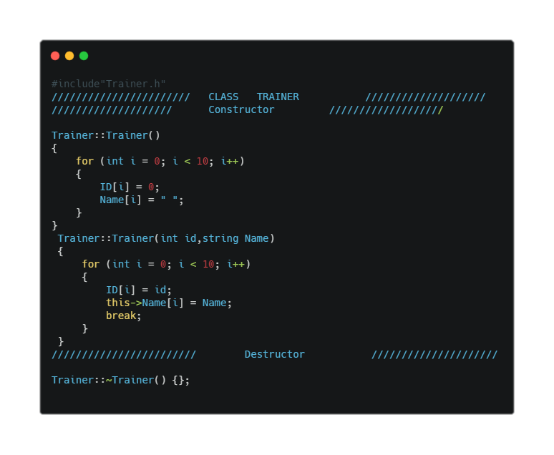

The AddTrainer() function takes three arguments. It checks whether the Id is null and then stores the data at that location.

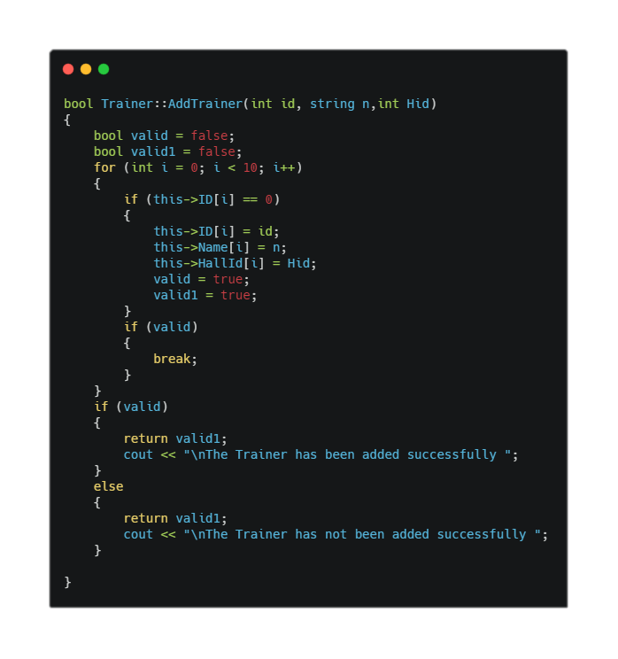

The**DeleteTrainer()** takes one argument and checks if the Id already exits or not if the Id exists it nulls all the Data Members at that location. If not it gives Error . Its return type is **bool.** 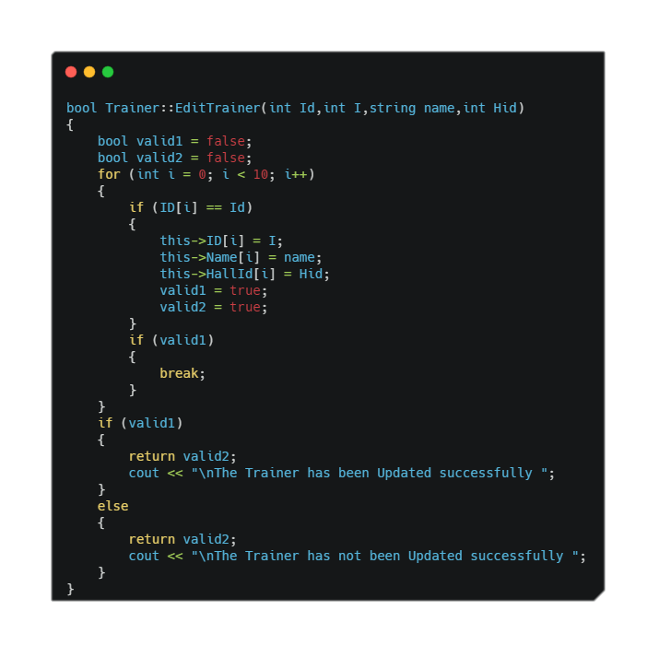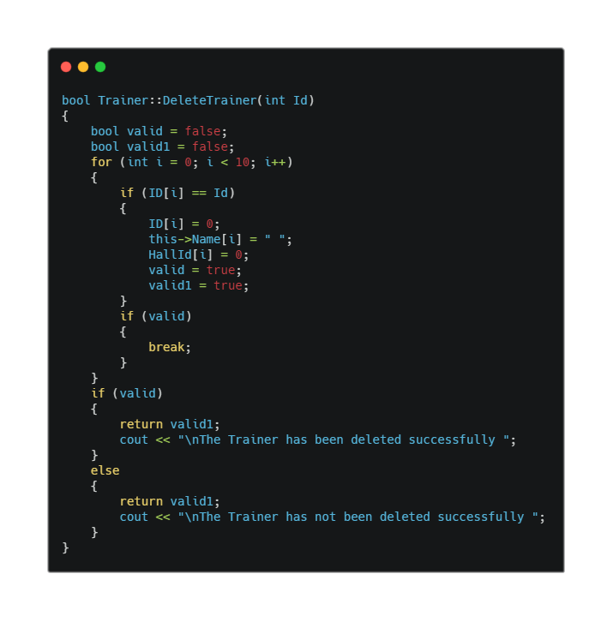

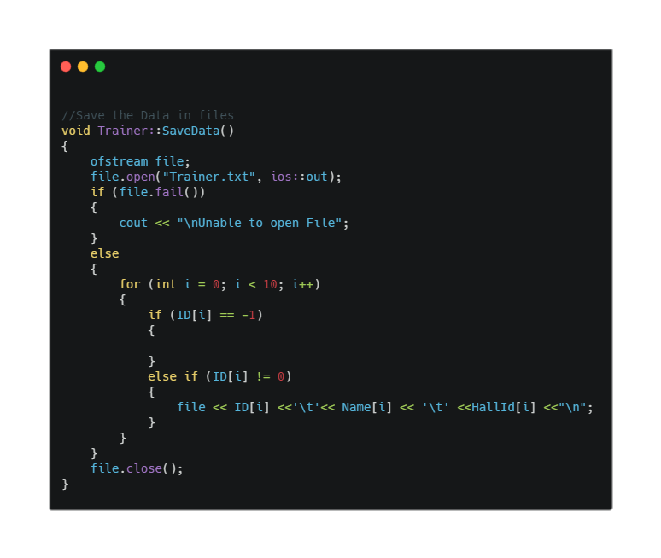The **SaveData()** function is used to save Data into the files if ID is not null and Ignoring the Id “-1”

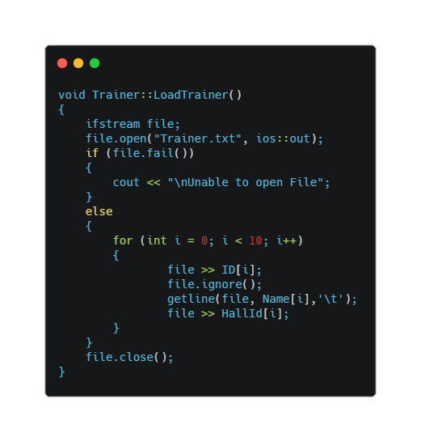The **LoadTrainer()** reads the file “Trainer.txt” and load the data in the Data.

The **LoadData(int Id)** functions take one argument (Id). It Loads the ID from the file and check whether the Id Exists in the file or not. Its return type is **Bool.**

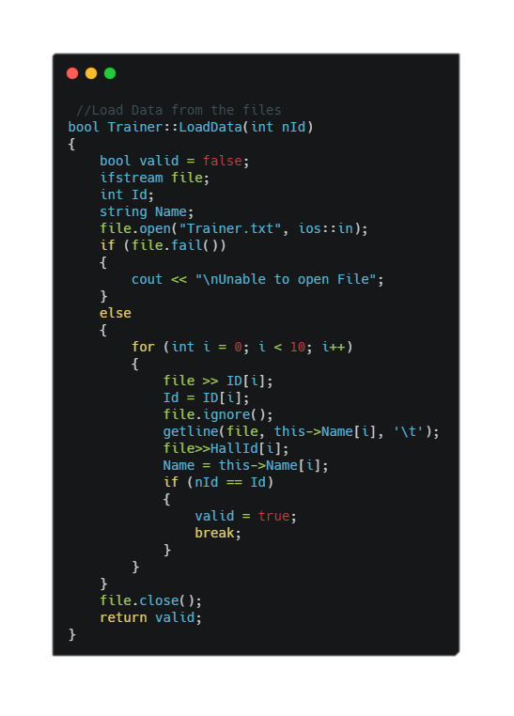

ExercisePlans:

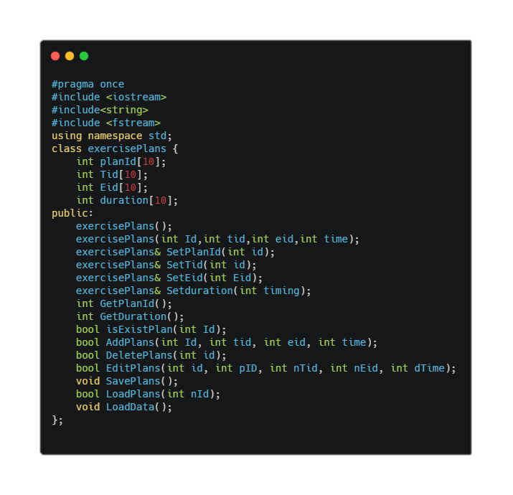 This class is responsible for **Adding/Deleting and Updating** the **ExercisePlans** based on the Trainer who sets and Exercise Plans for the Particular Equipment.

The Null Constructors sets all the Data Members to null.

The Setter and Getter functions are used to assign and get the Data from the Data Members.

The SavePlans() is used to write the Data into the Files.

The LoadPlans() is used to read data from the files and load the data into Data members.

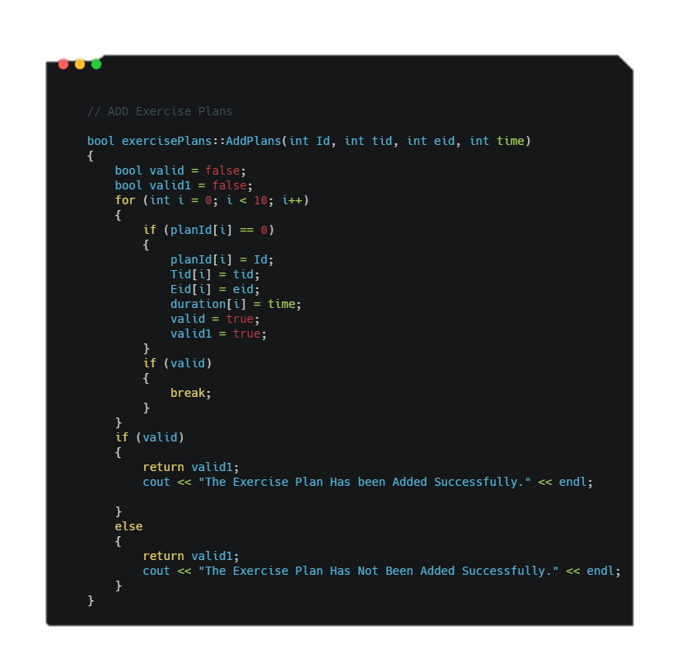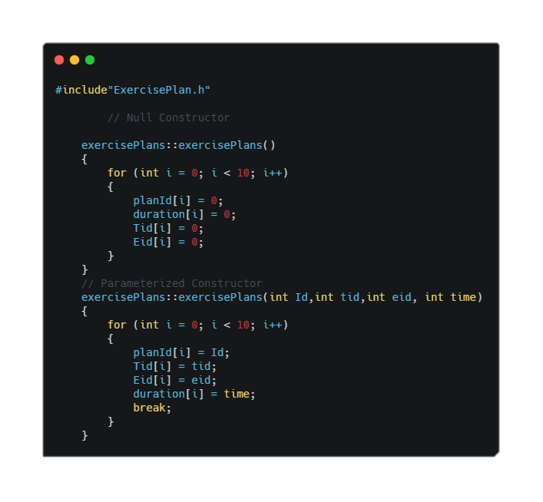The AddExercisePlan() function is used to add the data into members based on the same condition as all the previous Classes.

The DeletePlans() Plans function takes one argument and null all the Data Members if the Id matches.

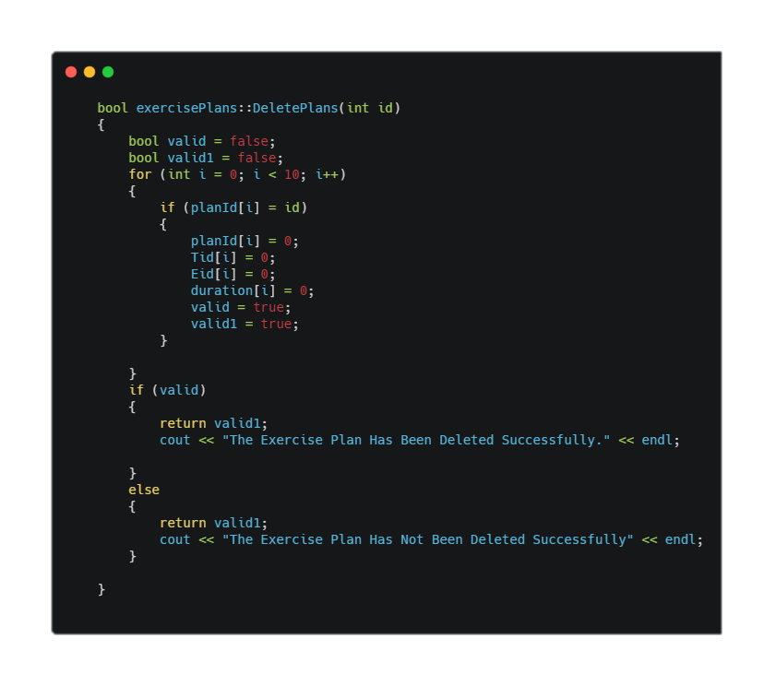

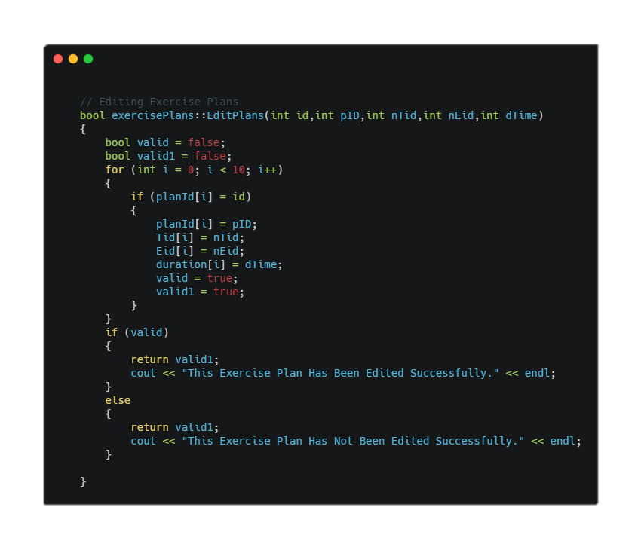The EditPlans() functions is used to change the saved data based on previously saved Id.

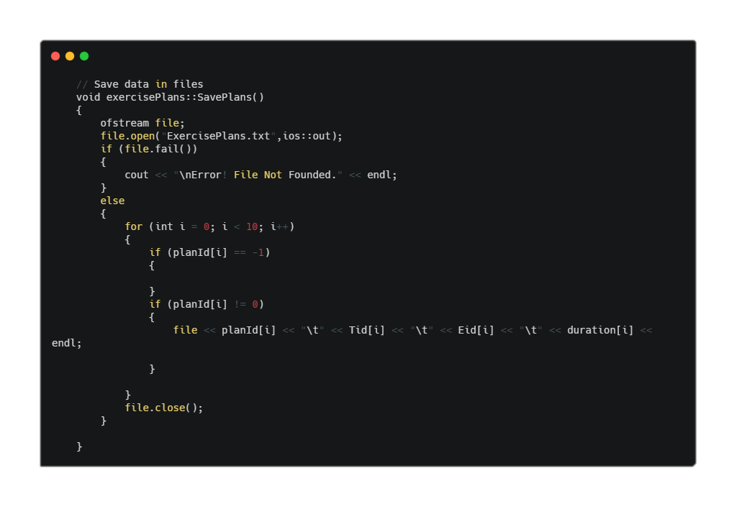The SavePlans() functions writes the data into “ExercisePlans.txt”

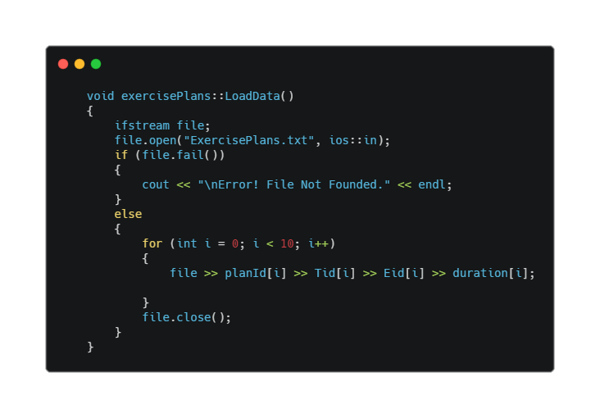LoadData() function reads the data from “ExercisePlans.txt ” and loads into its members.

Customers:

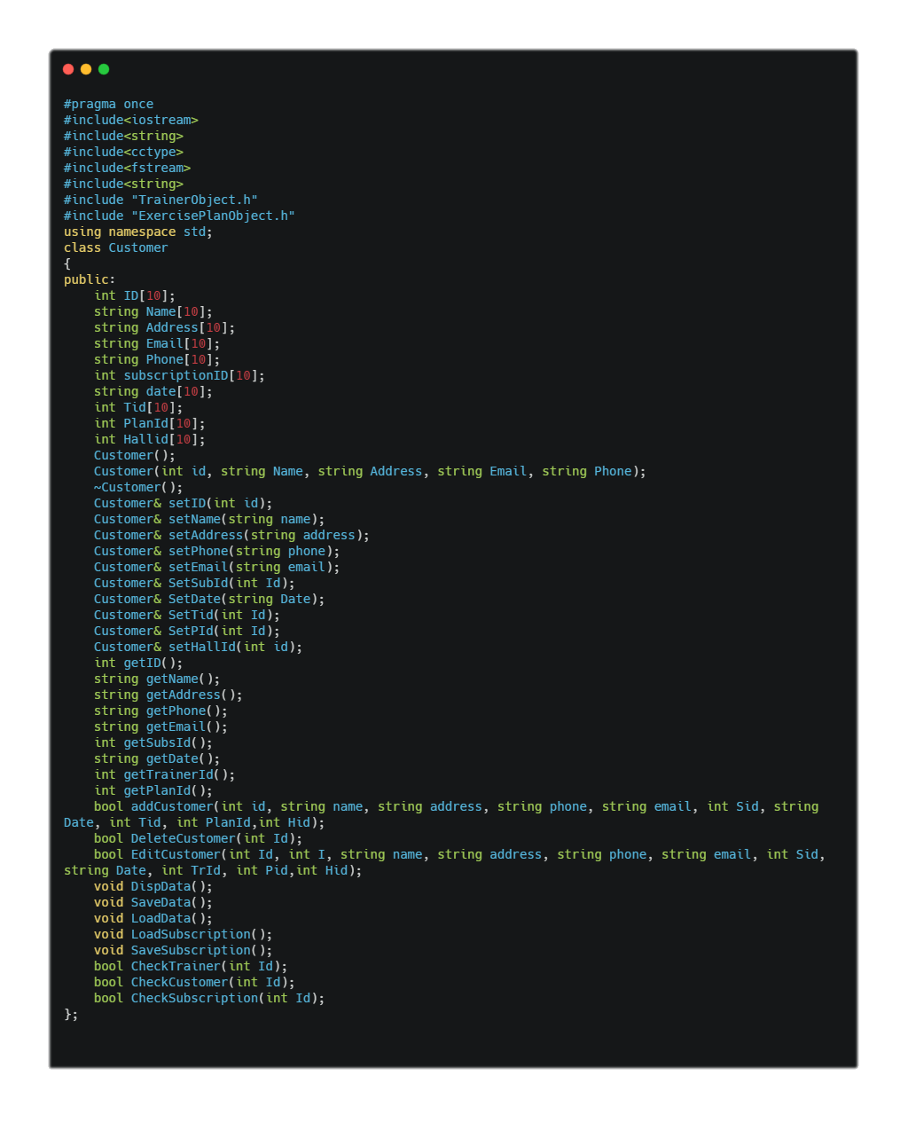 **Customers** class is the main class that is responsible for managing the customers Personal Information and its Gym Information.

The **Customers** class has **10** Data members. All the Data Members are **public**. The Data members of Id, Name, Address, Phone and Email are used to store the personal information of the User. The next Data members are used to store the Gym Information of the Customer.

The Null Constructor sets all data members to zero.

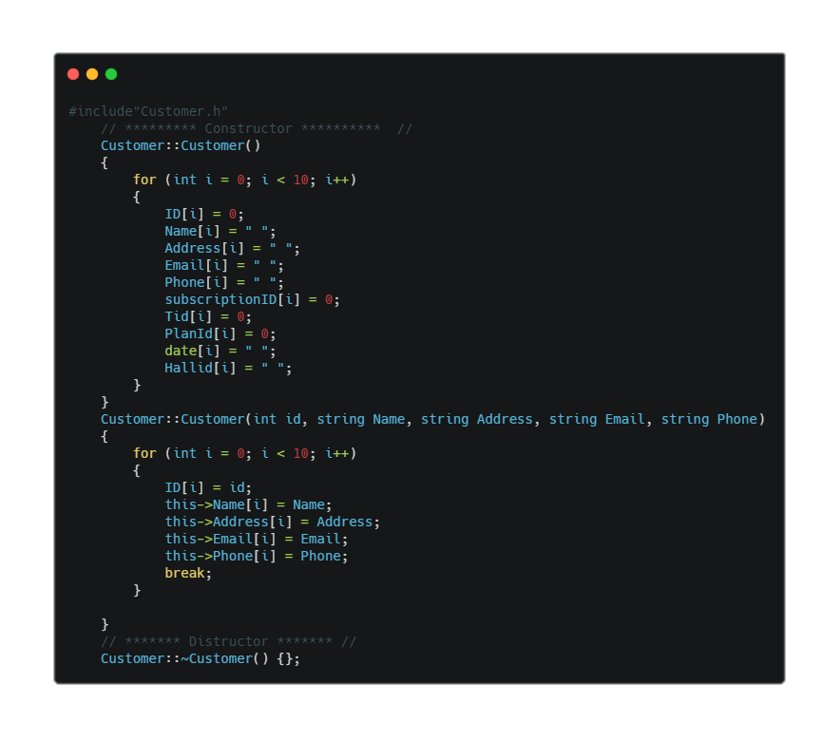

The setter and getter functions are used to set and get the data from the data members.

These functions are not mostly used in the project.

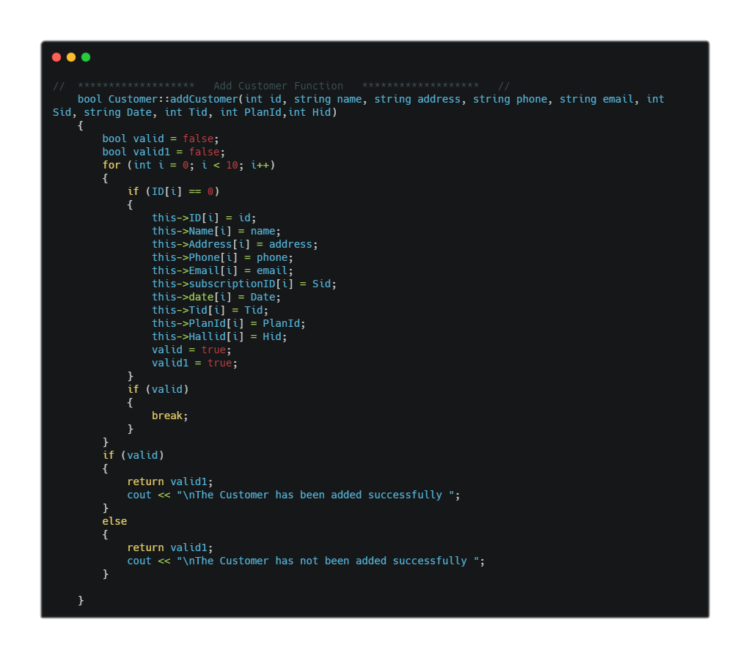The **AddCustomer()** function takes all the arguments and then add the data based on condition that id is zero. Its return type is **bool**.

The **DeleteCustomer()** function is used to delete the record of the customer by setting all the data members to null as in all the other classes.

The **EditCustomer()** function is used to update the data based on the previously saved data in the data members. Its return type is also **Bool**.

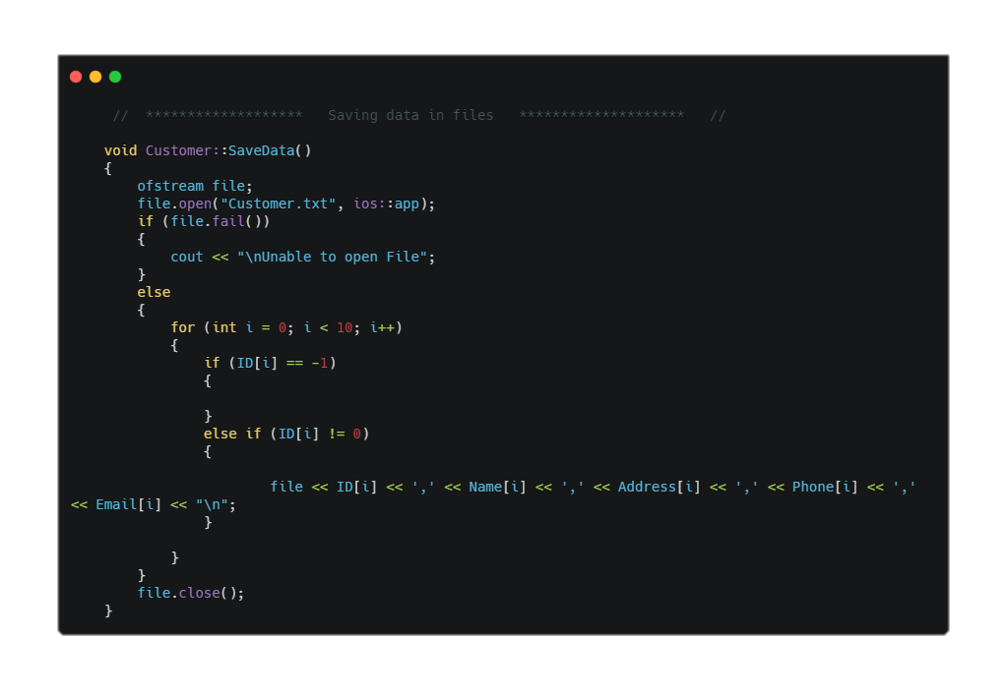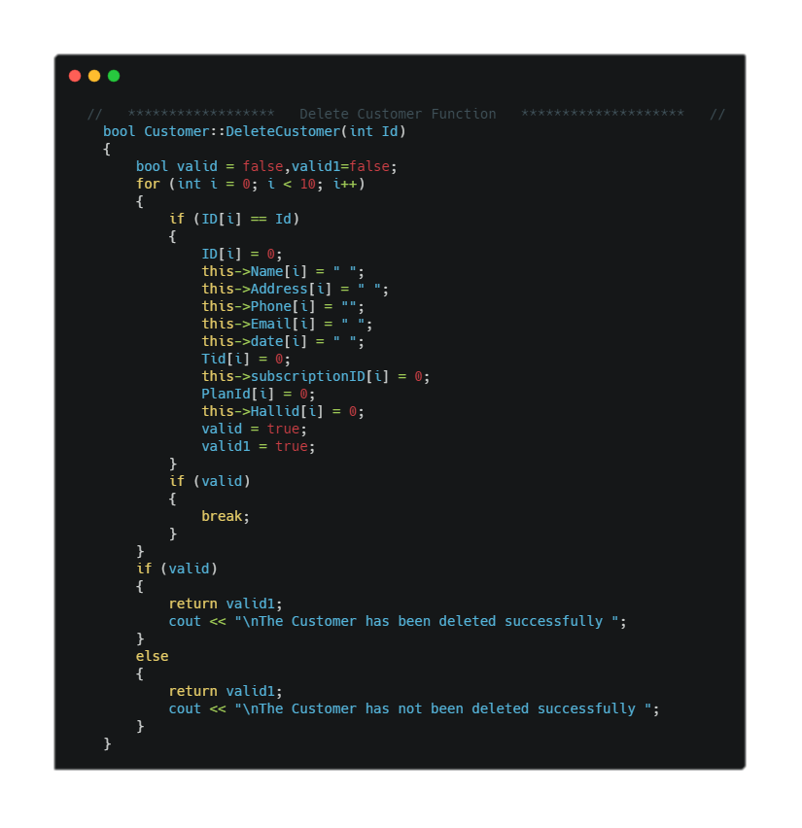The SaveData() function is used to write the data into the file “Customers.txt” and the

SaveSubscription() function is used to write the data into the “Subscription.txt”. These both functions are used frequently in the project.

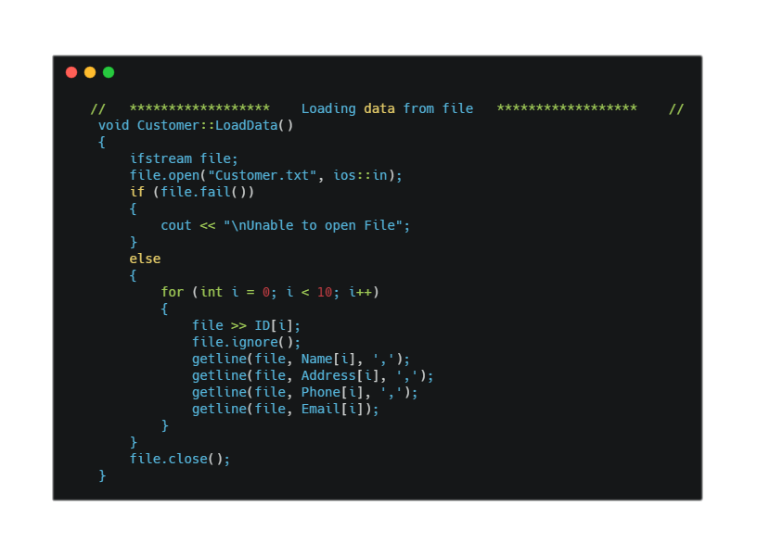The LoadData() function is used read data from the “Customer.txt” and load it into the data members.

The **LoadSubscription()** is used to read from “Subscription.txt” and load the data .

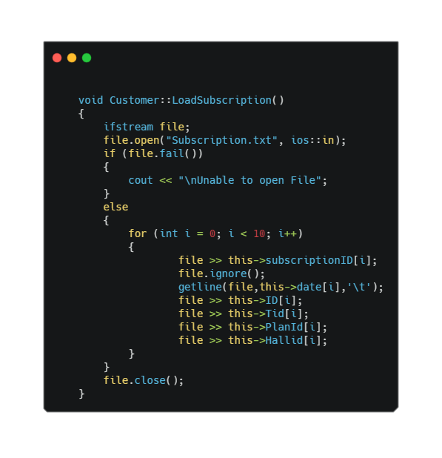

The remaining functions **CheckCustomers()**, **CheckTrainer()** are used to test whether the **Customer ID** and **Trainer Id** already Exists. These functions loads the data from the file **“Customer.txt”** and then check whether the Id entered by user already exists or not.

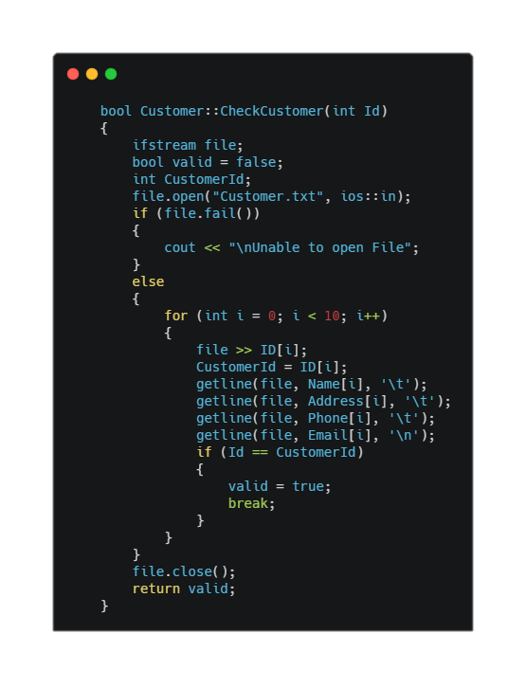

GymHalls:

This Class is responsible for adding/Deleting/Updating the GymHalls. All the other data of Customers is managed in the other Classes.

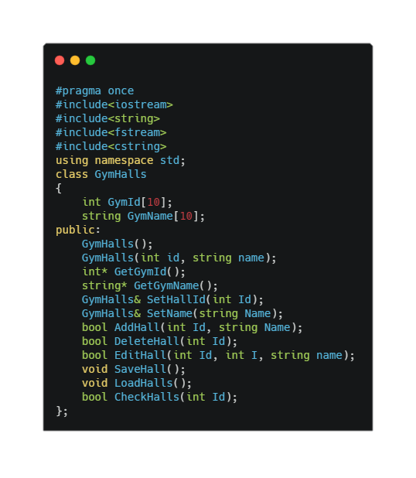

The Null Constructor sets all the data members to zero.

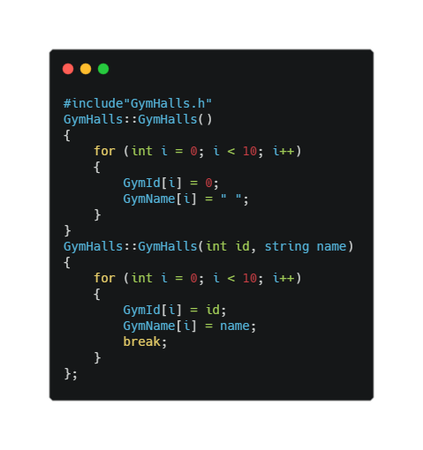

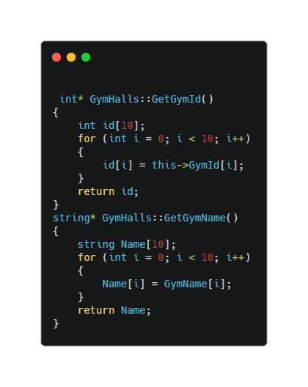The Setter and Getter functions are used to set and return the value from the data members.

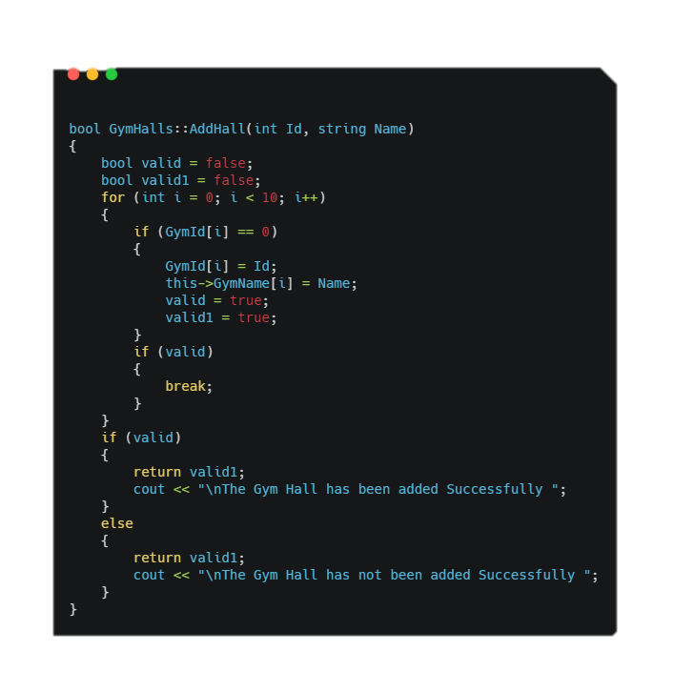The AddGymHall() function is used to add the data at the location where Hall Id is “Zero”.

The DeleteHall() and EditHall() functions work on the same logic. If the Hall Id exist then null all the data members at that location.

The EditHall() works if Hall Id exists then add the new data at the same Location. This is the same logic as in the previous classes.

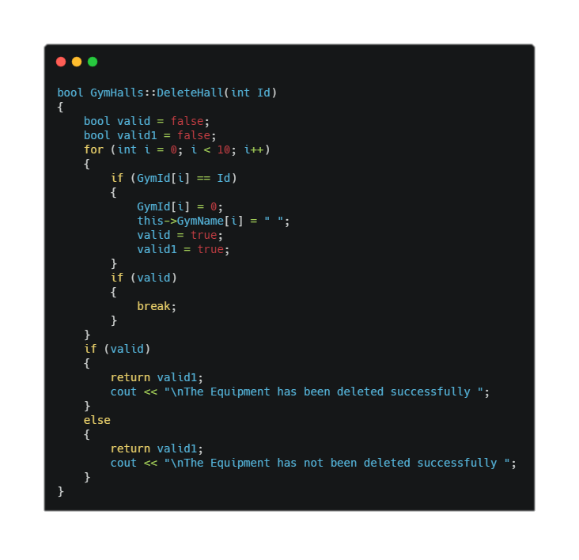

SaveHalls() and LoadHalls() are the functions used to write data into the files and then read the files and load the data into the data members.

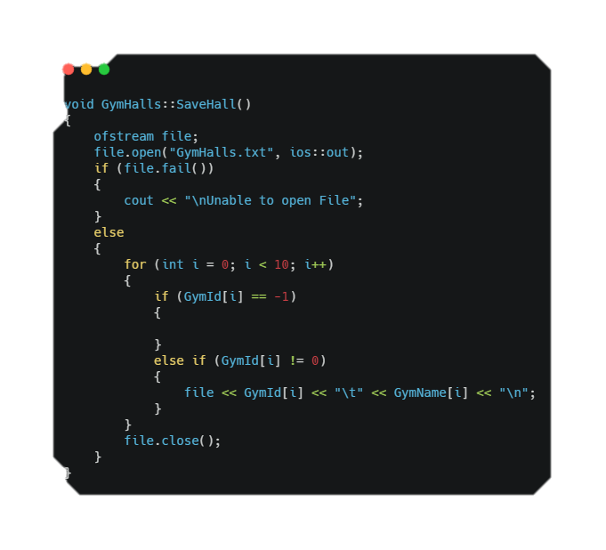

Detailed Explanation of GUI:

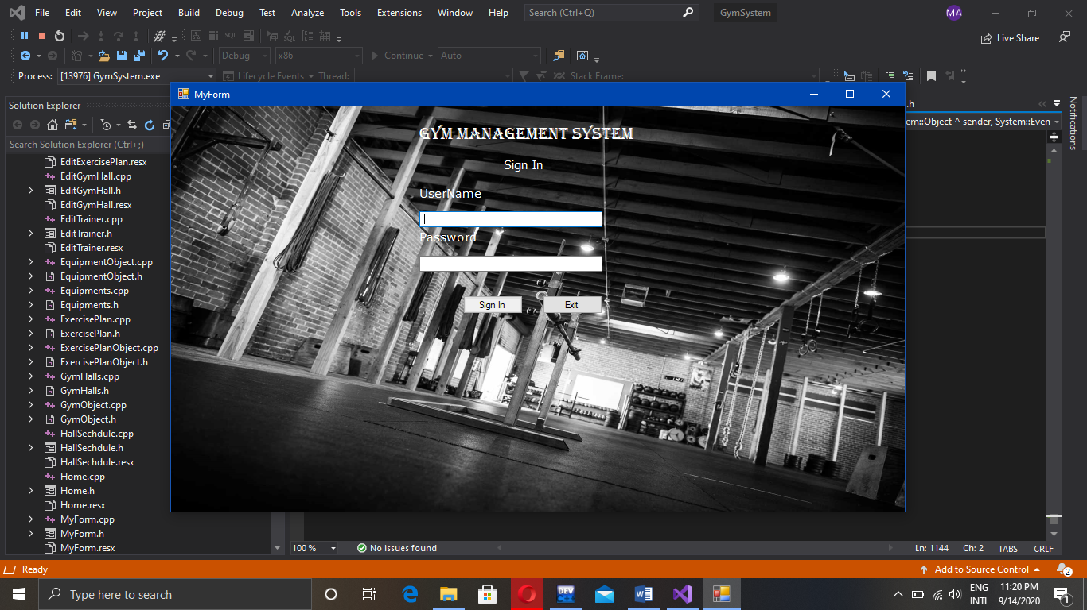 This project is a **Admin Side** desktop Application for managing the Gym with its Equipments, Trainers, Plans, Customers and the Gym Halls. The Application stores all the Data in the separate files according to the separate type of the things.

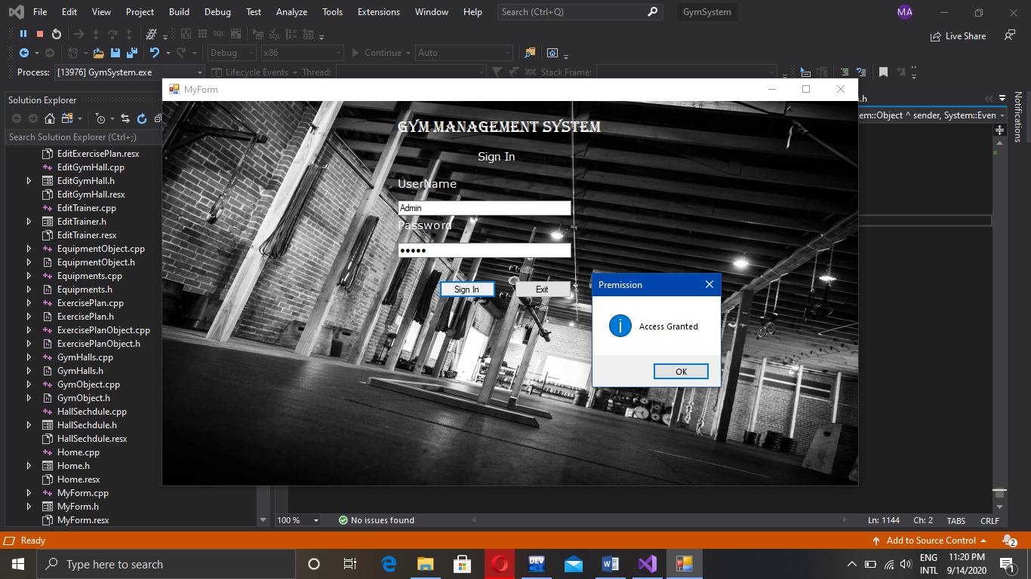This is the main login page of the Application. After entering the **Username** and **Password**. Click the **Sign In button** and your data will be checked.

After Successfully signing in to the Application. You will see this message.

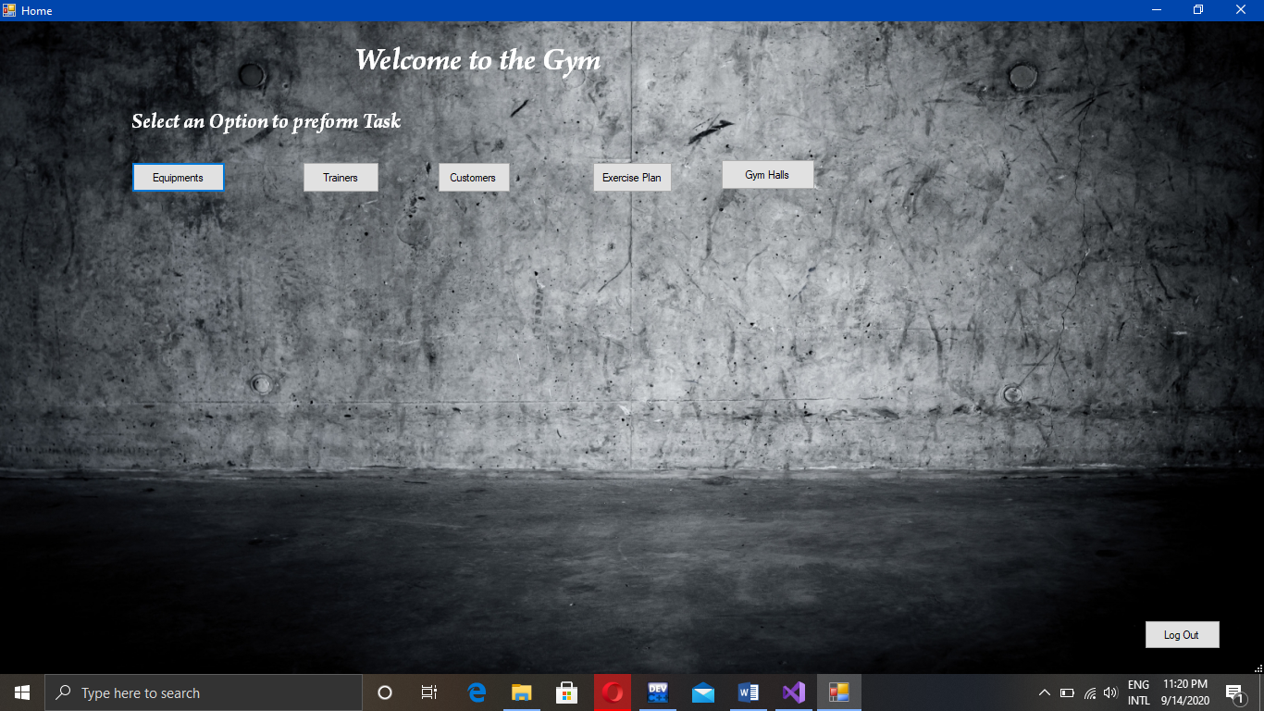This is the Main layout of the Application. There are five buttons each handles a single class. When you click any of the button a drop down menu will appear and you can select any of the Options.

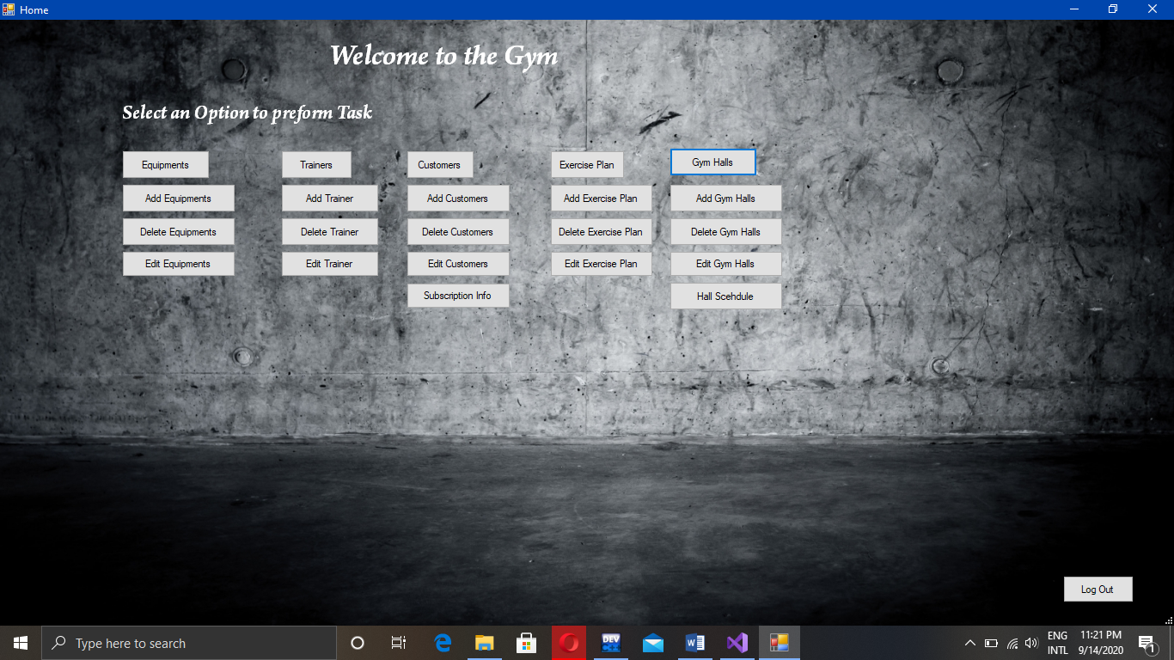

There you can see below each button there are basically three main functions of adding/deleting and updating the data managed in each class.

So, in order of use the application you need to add the Hall first where you can add all the other things like equipments etc.

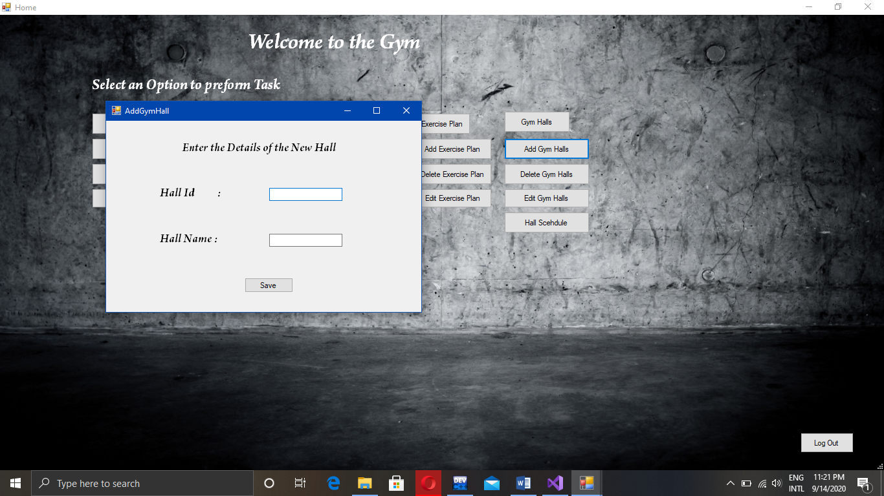So, when you click the **“Add Gym Hall”** you will see a dialogue box like this. So, you fill the required Information Hall Id and Hall Name. When you click **Save** your entered data will be processed and checked by application.

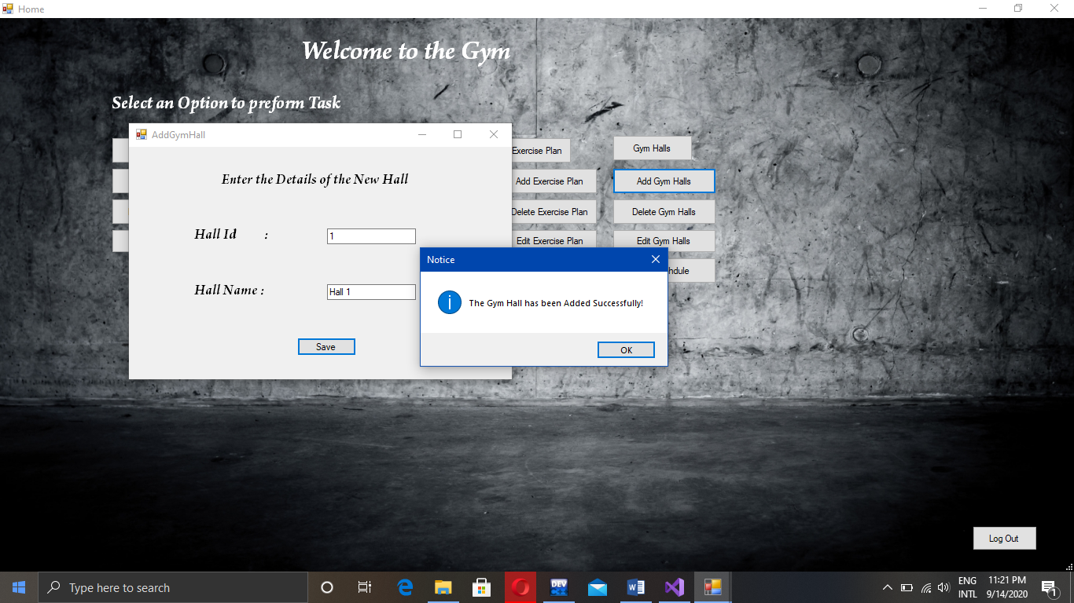

If the entered data is correct then you will see this “Message Box” and the data will be saved.

If you want to delete the hall information, then you will click the “Delete Gym Hall”.

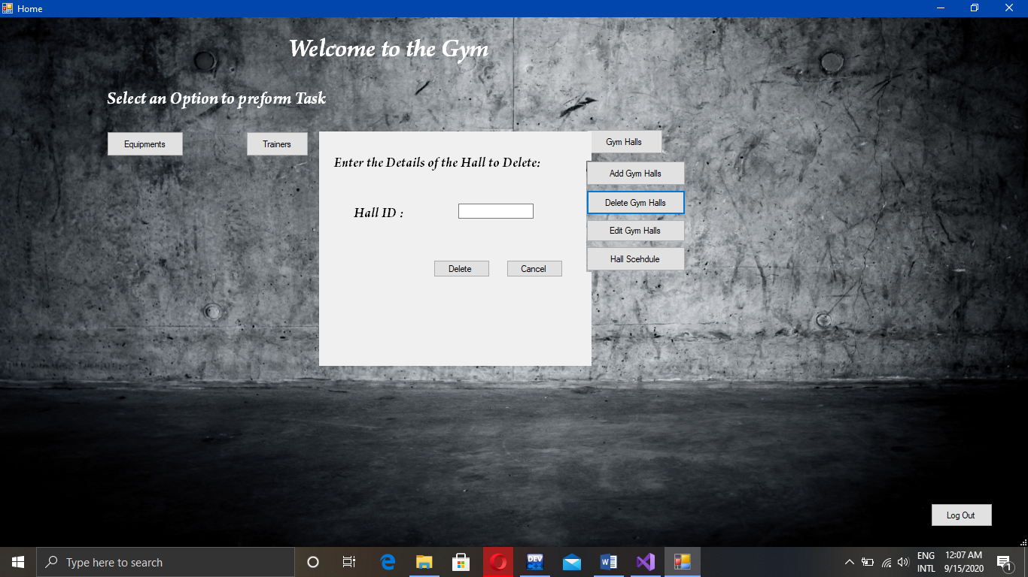

So, enter the hall id you want to delete and click **“Delete”.** If id exist the Hall info will be deleted.

If you want to edit the Hall information. Then use “Edit Gym Hall.

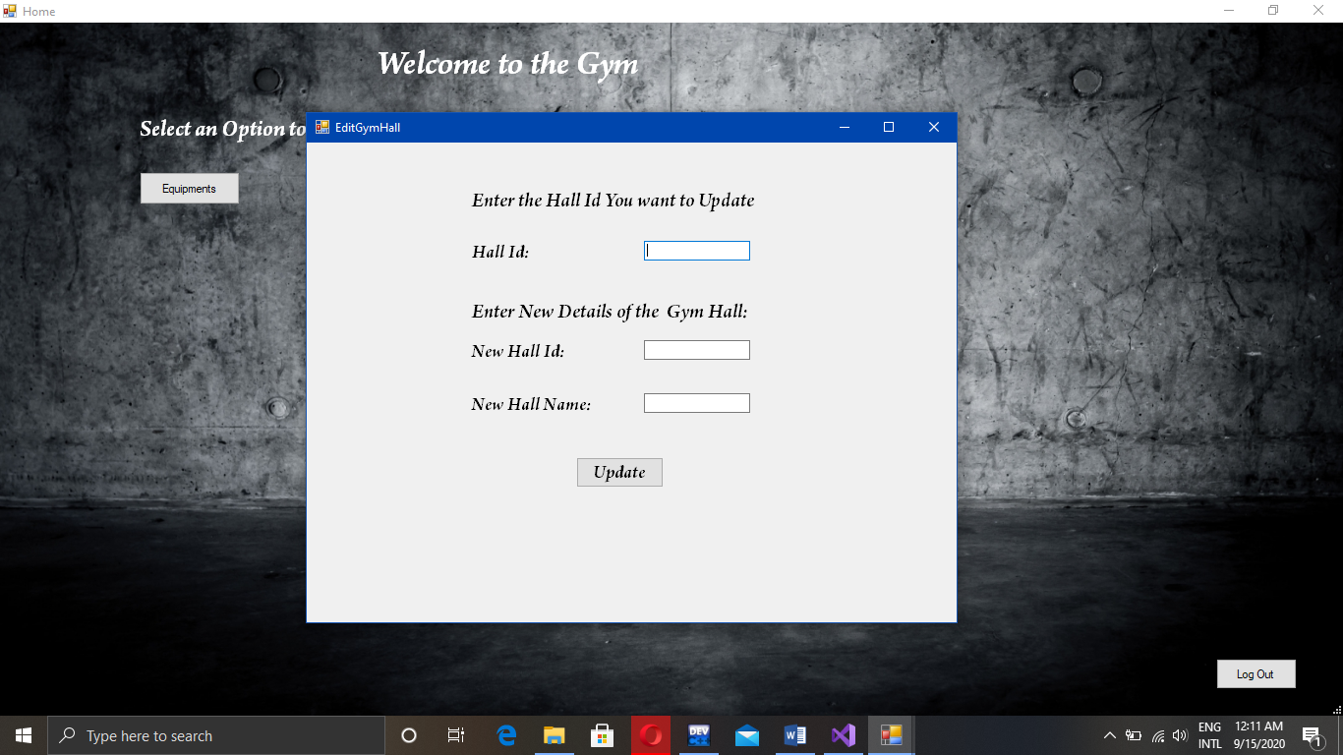

Now, in order to update the information you must enter above shown information. After data is added correctly. The data will be updated.

After adding the Hall you need to add the “Equipments and Trainers” in order to create an “Exercise Plan”.

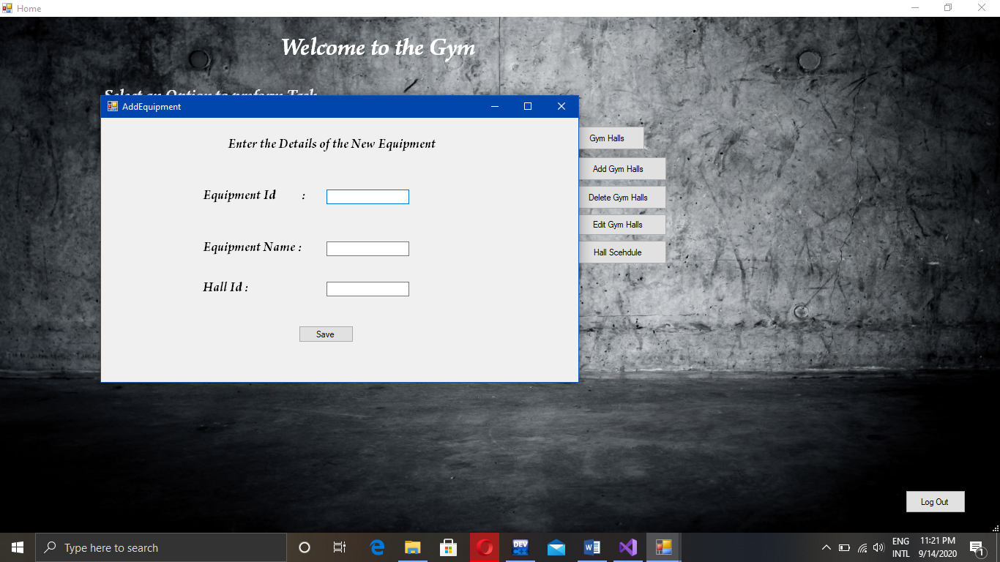

Now, first add the Equipment and also the Hall where you want to add the Equipment. If

The Equipment already exists or the Hall id does not exist then error message will be displayed.

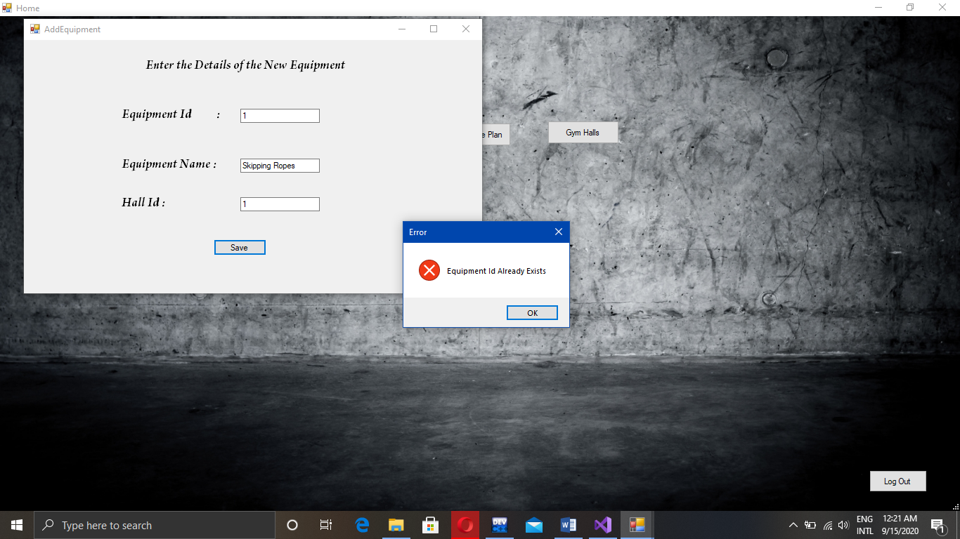

This error message will be displayed if you enter existing Equipment details.

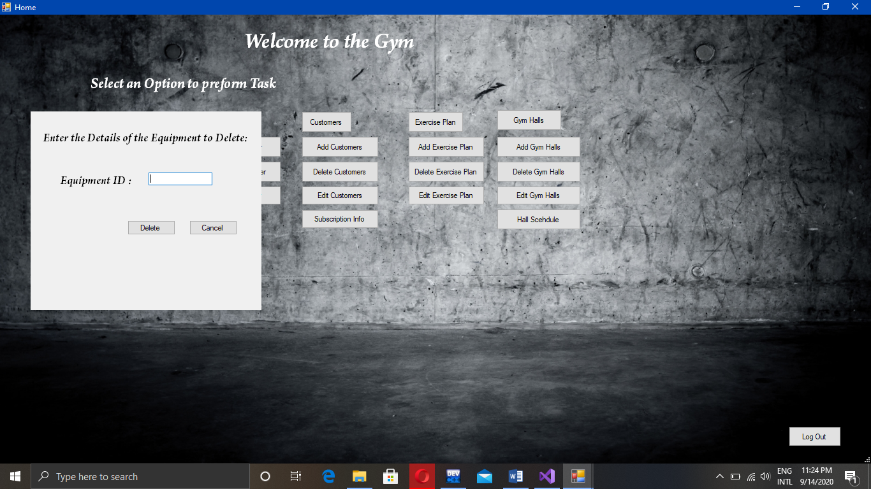Now, you will enter the Equipment id you want to delete and if it exists then, the data will be deleted.

If you want edit the Equipments then you will click the “Edit Equipments”.

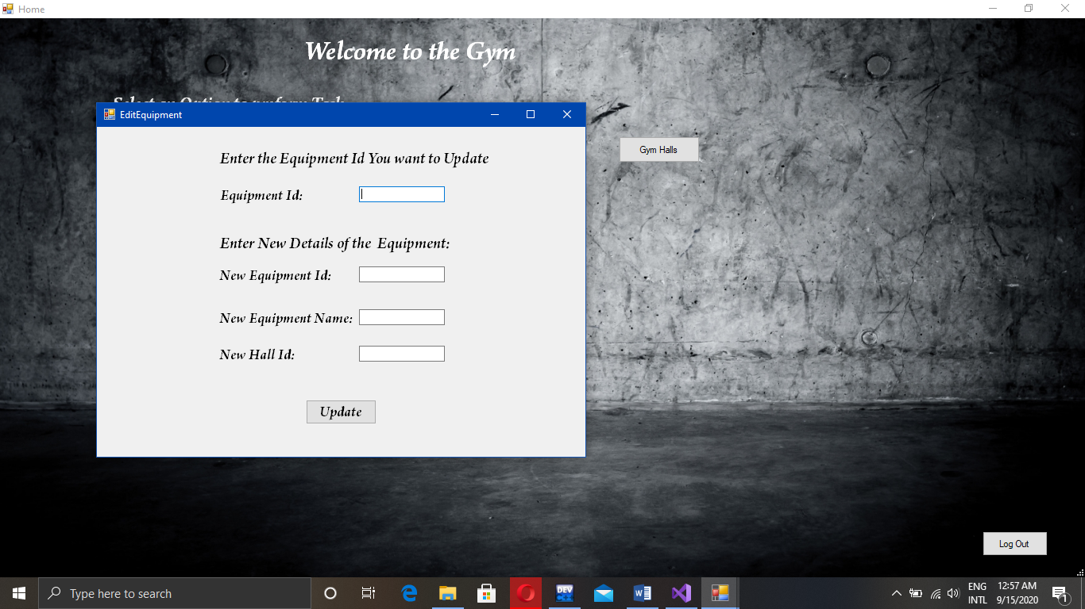

After adding the required information. The Equipment will be Deleted.

The Adding/Deleting and Updating the Trainer is same as the Equipment.

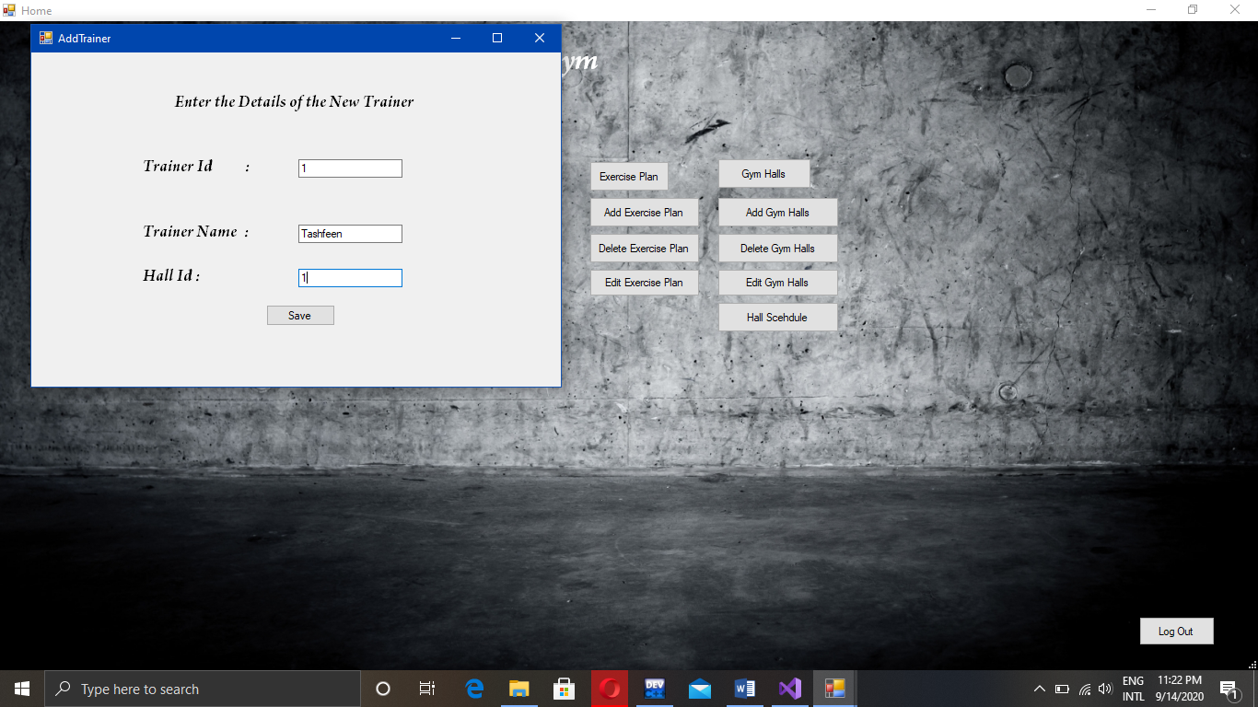So, in order to add the trainer you need to enter the required information. If all the data is valid then the Trainer will be added.

Now in order to add an Exercise Plan click on “Add Exercise Plan”.

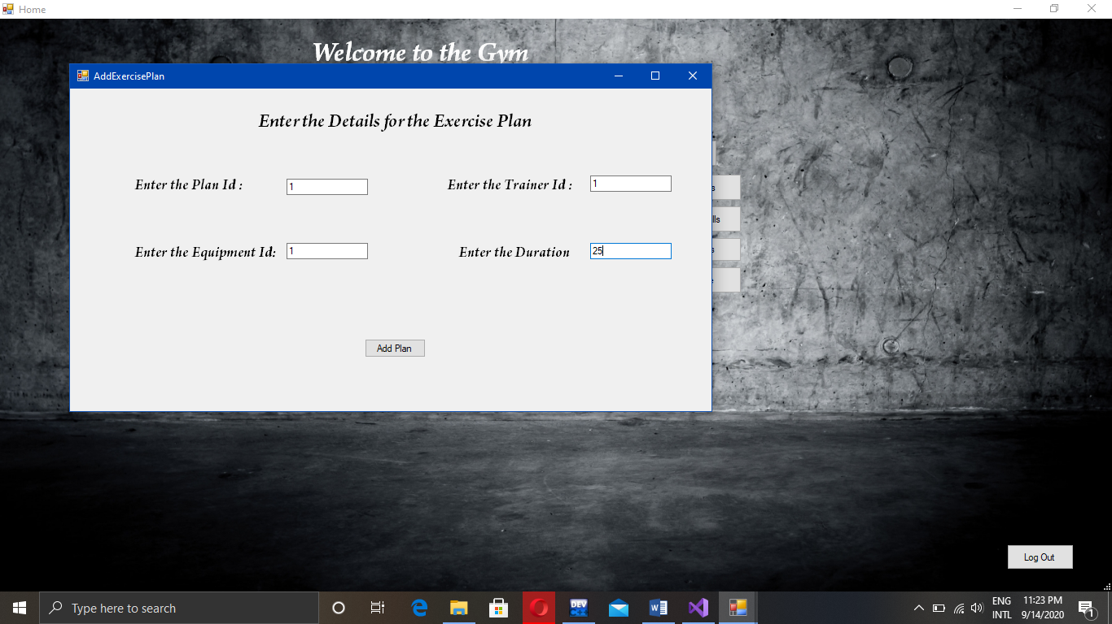

In order to add “Exercise Plan” you must add “Equipment and Trainer” or the Error message will be displayed.

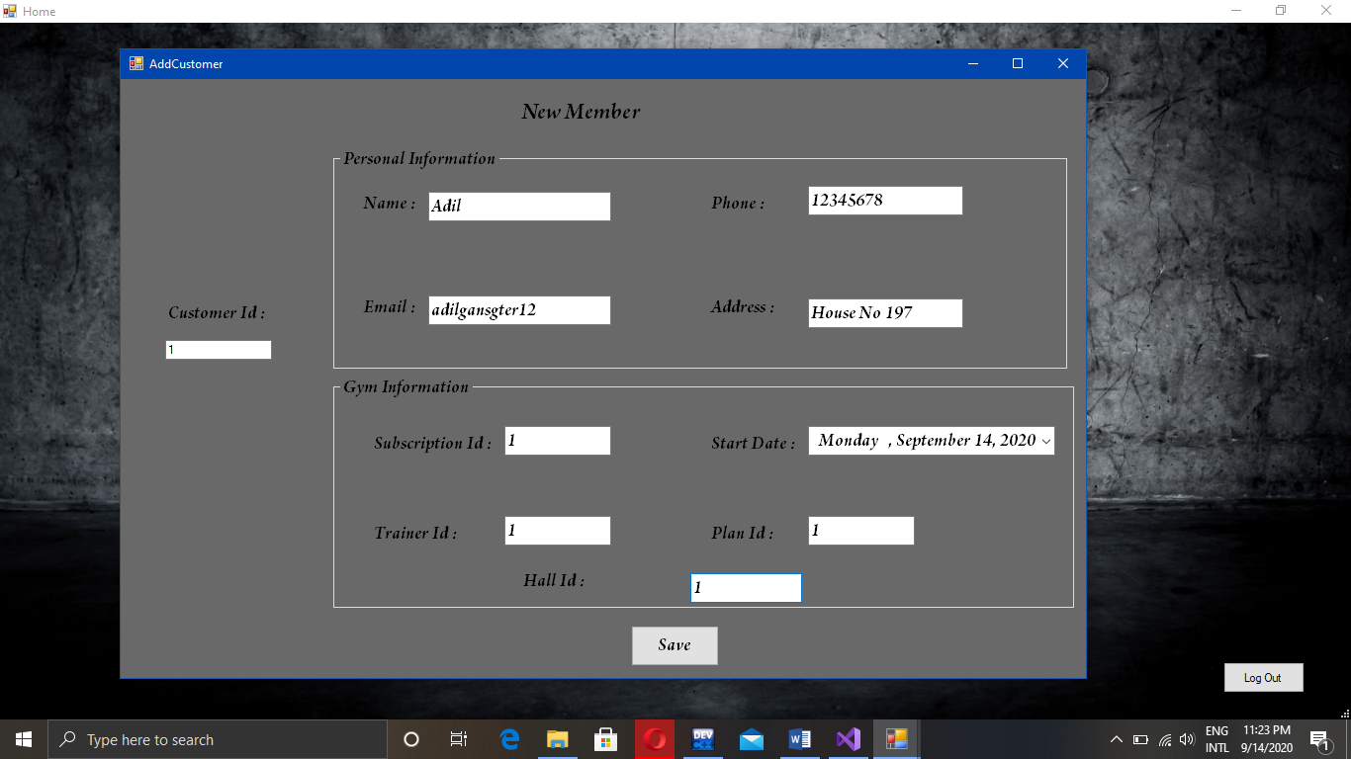

So, when you click on “Add Customer” the above information form will be displayed. Fill the information and then click “Save”. If all the information is correct then the data will be added.

Now if you want to see the stored data click on “Subscription Information”.

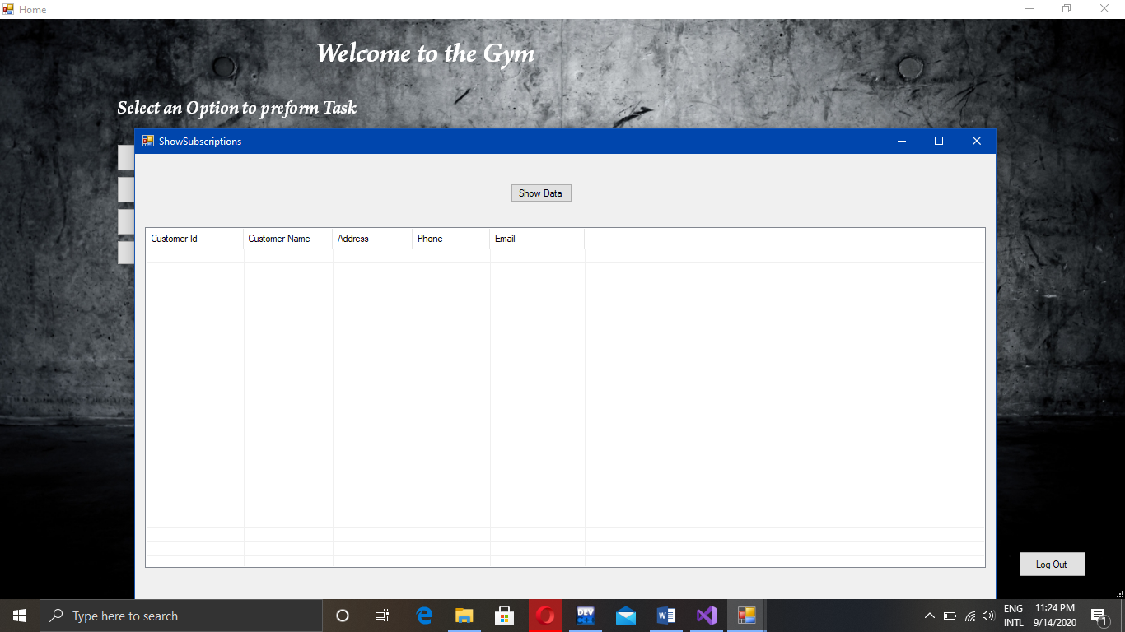

After clicking you will see the above show table. Now, click the “Show Data” button and data will be displayed like this:

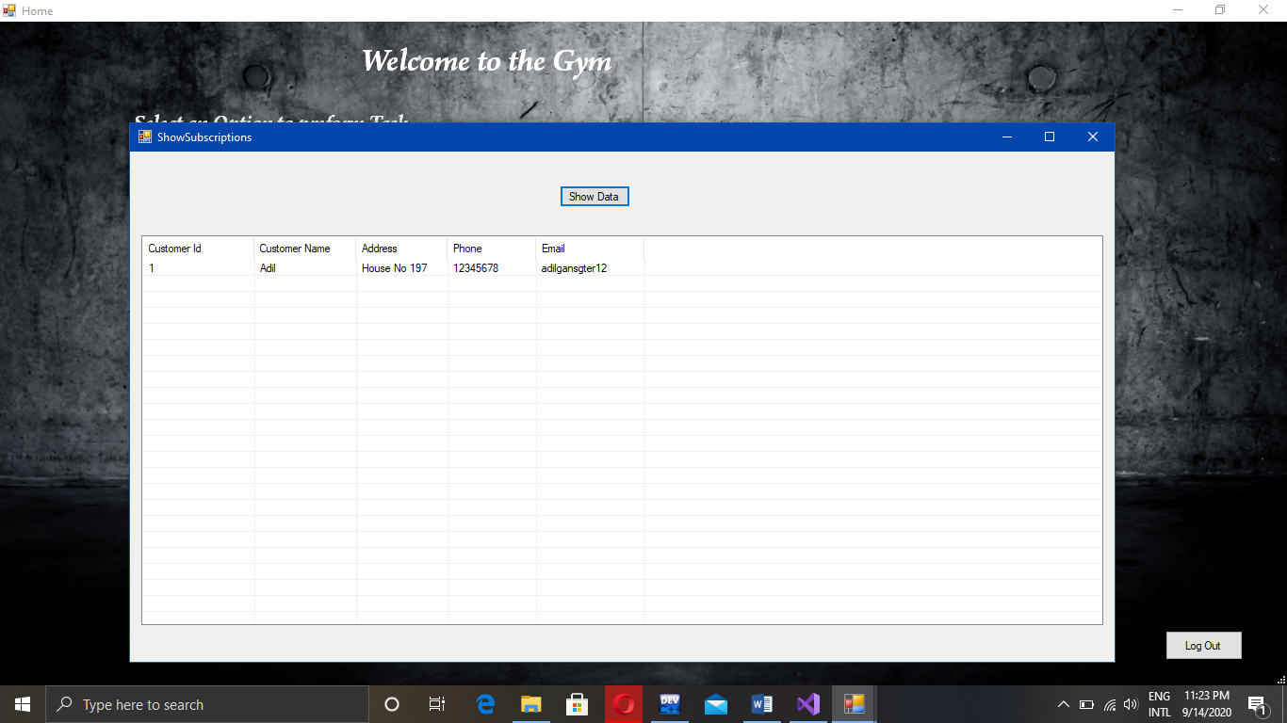This is how data will be displayed as show in the above picture.



On clicking the “Log Out” button you will return to the “Login Page”

UML Diagram of the Project:

Equipments Trainers

int EquipID[10];

string Name[10];

int HallId[10];

Equipments();

Equipments(int id, string name);

int getEquipID();

string getName();

Equipments& setEquipID(int id);

Equipments& setName(string name);

Equipments& setHallid(int id);

void printDetail();

bool AddEquipment(int Id, string Name,int Hid);

bool DeleteEquipment(int Id);

bool EditEquipment(int Id, int nId, string nName,int Hid);

void SaveEquipments();

bool LoadData(int nId);

void LoadEquipments();

bool isExistId(int Id);

int ID[10];

string Name[10];

int HallId[10];

Trainer();

Trainer(int id,string Name);

~Trainer();

Trainer& setID(int id);

Trainer& setName(string name);

Trainer& setHallId(int id);

int getID();

string getName();

bool isExistTrainer(int Id);

bool AddTrainer(int id, string n,int Hid);

bool DeleteTrainer(int Id);

bool EditTrainer(int Id,int nId, string Name,int Hid);

void DispData();

void SaveData();

bool LoadData(int nId);

void LoadTrainer();

Customer Exercise Plans

int planId[10];

int Tid[10];

int Eid[10];

int duration[10];

exercisePlans();

exercisePlans(int Id,int tid,int eid,int time);

exercisePlans& SetPlanId(int id);

exercisePlans& SetTid(int id);

exercisePlans& SetEid(int Eid);

exercisePlans& Setduration(int timing);

int GetPlanId();

int GetDuration();

bool isExistPlan(int Id);

bool AddPlans(int Id, int tid, int eid, int time);

bool DeletePlans(int id);

bool EditPlans(int id, int pID, int nTid, int nEid, int dTime);

void SavePlans();

bool LoadPlans(int nId);

void LoadData();

int ID[10];

string Name[10];

string Address[10];

string Email[10];

string Phone[10];

int subscriptionID[10];

string date[10];

int Tid[10];

int PlanId[10];

int Hallid[10];

Customer();

Customer(int id, string Name, string Address, string Email, string Phone);

~Customer();

Customer& setID(int id);

Customer& setName(string name);

Customer& setAddress(string address);

Customer& setPhone(string phone);

Customer& setEmail(string email);

Customer& SetSubId(int Id);

Customer& SetDate(string Date);

Customer& SetTid(int Id);

Customer& SetPId(int Id);

Customer& setHallId(int id);

int getID();

string getName();

string getAddress();

string getPhone();

string getEmail();

int getSubsId();

string getDate();

int getTrainerId();

int getPlanId();

bool addCustomer(int id, string name, string address, string phone, string email, int Sid, string Date, int Tid, int PlanId,int Hid);

bool DeleteCustomer(int Id);

bool EditCustomer(int Id, int I, string name, string address, string phone, string email, int Sid, string Date, int TrId, int Pid,int Hid);

void DispData();

void SaveData();

void LoadData();

void LoadSubscription();

void SaveSubscription();

bool CheckTrainer(int Id);

bool CheckCustomer(int Id);

bool CheckSubscription(int Id);

Gym Halls

int GymId[10];

string GymName[10];

GymHalls();

GymHalls(int id, string name);

int* GetGymId();

string* GetGymName();

GymHalls& SetHallId(int Id);

GymHalls& SetName(string Name);

bool AddHall(int Id, string Name);

bool DeleteHall(int Id);

bool EditHall(int Id, int I, string name);

void SaveHall();

void LoadHalls();

bool CheckHalls(int Id);

Contributions:

* **Muhammad Adil(2019-CS-20)** is the **Group Leader** performing the **Project Analysis**, **Distribution of tasks** among the members, **Developing GymHalls** **Class**, **Developing GUI** and **Integrating the Classes** in **GUI**, also **Refractor the Code of Team Members** to meet the Needs of the **GUI** and **Handling Storage of Data on files**. I am also the main writer of this **Documentation**.
* **Uzair Tasawar(2019-CS-33)** developed the **Class Trainer** to work on console.
* **Syed Qaiser(2019-CS-34)** developed the **Class ExercisePlans** to work on properly console. He also helped in the **Documentation.**
* **Mazhar Khaild(2019-CS-35)** tried his best to develop the **Class Equipments** but it was completely changed in order to work properly on console and for the integration in GUI.
* **Amjad Khan(2019-CS-45)** developed the **Class Customer** with **only Basic information**. **Subscription Portion** of the **Class Customer** was completed by **Leader** to work properly on Console. He also helped in the **documentation.**

Learning Outcomes:

* Muhammad Adil(2019-CS-20), I have learned how to develop desktop application and use of the **GUI** in C++. I have also learned how to practically implement many other OOP concepts. I also learned that it is impossible to work alone if you group is not taking part actively.